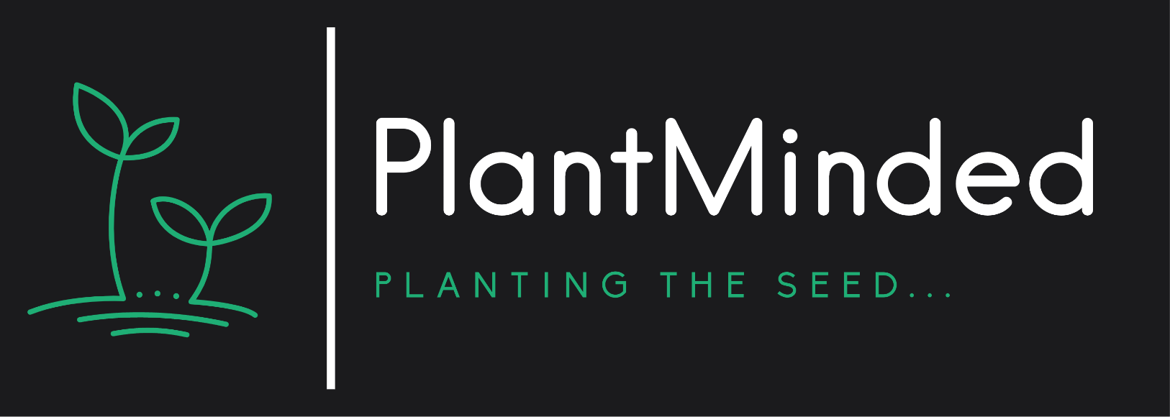

**PLANTMINDED**

***Social Media Policy***

**Purpose of Policy**

Here at PlantMinded we encourage employees to have an active voice and presence on social media. Whether you’re establishing relationships with potential prospects or engaging current customers, we know that social communities are where people communicate.

We have compiled the following guidelines for you to make the most of your social media network as an employee of PlantMinded. We want to embrace open communication and we encourage you to post about your experiences at PlantMinded. Below, you’ll ﬁnd our policies for posting and engaging on social media and other online spaces to ensure our employees and our brand are protected.

**Who the Policy Applies To**

PlantMinded’s social media policy applies to all team members,

as well as freelancers and interns, who use social media during or after work to post company-related information.

Company-related information includes:

* 1. Photos or videos taken at work or at company-sponsored events.
  2. Photos or videos taken of fellow team members.
  3. Confidential or personal information pertaining to clients, prospects or employees.
  4. Company-owned content such as blogs, presentations, videos etc.

**Who the Policy Applies To**

Social media includes:

1. Any online platform where you may be interacting with others—personally or professionally—such as Facebook, Twitter, LinkedIn, etc.
2. Photo-sharing networks such as Instagram and Snapchat
3. Video-sharing networks such as YouTube or TikTok
4. Discussion forums such as Reddit
5. Q&A-based networks such as Quora
6. Review platforms such as Yelp or Google

Always review your content before posting. Review grammar and spelling and do a fact check to ensure the information you share is accurate.

If you’re unsure about the content you want to share, email Evelyn McDade at [plantmindedgardens@gmail.com](mailto:plantmindedgardens@gmail.com)

**Personal Account Guidelines and Company Association Rules**

**The dos ✓**

Here’s a list of dos and don'ts to consider to stay compliant with our policy:

* Write in ﬁrst person to make it clear you aren’t speaking on behalf of the company. A great way to do this is to include “all opinions are my own,” in your social proﬁle bio.
* Read and follow PlantMinded’s Code of Conduct and Employee Handbook before posting to further familiarize yourself with how and why we use these policies.
* Share audience questions or feedback with our social media team.
* Connect and interact with relevant prospects and/or customers.
* Monitor competitor or company accounts.

**The Dont’s**

* React to negative or oﬀensive posts about PlantMinded or our employees. Share the post(s) with our team at PlantMinded.
* Share sensitive information about our employees, customers, partners,
* Post inappropriate or oﬀensive messages/images.
* Post content published by competitors.
* Answer audience questions that do not pertain to your ﬁeld of expertise (instead, direct them to a relevant employee).
* Post material that could be interpreted as libelous or defamatory.
* Share content that may damage the company’s public image.
* Discuss employees, customers, partners, and suppliers without their expressed consent.
* Harass others by sending them oﬀensive content or messages.
* Communicate with company competitors in a disrespectful manner.
* Distribute spam and chain messages.

If you have questions regarding what is acceptable and unacceptable to post as an employee advocate, please speak to PlantMinded owner and operator, Evelyn McDade.

**Other Rules to Follow**

**Friend/Fan Requests**

Being a visible brand online, you will inevitably receive “friend” requests through sites like Twitter, Facebook, Instagram and LinkedIn. It is totally up to you whether you are comfortable accepting these requests.

**Privacy Settings**

Be mindful of the information you’re sharing about yourself and your family. Each network has speciﬁc privacy settings to help you control which information you share—choose only information you feel comfortable disclosing.

Interacting on behalf of PlantMinded

If your particular role at PlantMinded

has you interacting with folks on social

**NOTE:**

Expand the height of the rectangle to allow adequate space for answers.

media, please be sure that you are properly identiﬁed with your title and a link to the company @plantmindgardens.

**Personal Information**

It’s never okay to share personal information about any other team members such as their name or location unless veriﬁed by the team member. Be careful about what you mention online from your personal account.

**Social Media and Employee Advocacy**

Knowing that employee advocacy yields clear company beneﬁts—such as amplifying content reach, boosting engagement and driving lead

Generation, PlantMinded

what employees post.

understands that there are nuances around

Employees use social media not only to build their personal brands, but to promote the company at large. Therefore, it’s important to develop a set of mutually agreed-upon guidelines.

Employees can help amplify PlantMinded’s

cross-departmental initiatives by:

brand and

* + Posting original content pieces such as blog posts, webinars and infographics

**NOTE:**

Expand the height of the rectangle to allow adequate space for answers.

* + Sharing third-party (curated) content pieces relevant to target audiences
  + Announcing special oﬀers, events and contests
  + Promoting product demonstrations or how-to guides
  + Engaging with audience members, including providing timely responses
  + Monitoring social channels for brand mentions, customer questions and competitor activity

**Social Media Team Protocols**

PlantMinded

’s social media accounts must only be used and created by

authorized individuals for the purpose of meeting deﬁned company goals. Goals and purposes of PlantMinded ’s brand on social media:

* Build strong relationships with clients and prospects
* Drive traﬃc to the company website
* Ensure quality after-service, customer service

**Publishing**

When drafting comments, staﬀ must maintain the highest levels of courtesy and professionalism, particularly when dealing with diﬃcult or emotionally charged situations—including careful attention to detail, accuracy, and grammar. All comments and posts should always clearly identify you as an employee representing PlantMinded . All posts should be consistent with our company’s overall mission, priorities, and philosophy.

If you make a factual error in a post, update it with a correction. Deleting or editing the original post should come at your own discretion, depending on the situation. In case of a social media blunder, don’t walk away—address the mistake and rectify the situation with an apology or private message.

**Questions**

Any questions directed to our company should ideally be answered as quickly and completely as possible. If you are unsure of the answer, let the customer or prospect know that you're looking into their question and will respond as soon as you have more information.

If someone asks a question via social media, they will likely want to have their question answered there as well. However, if you would like to make the discussion private or prefer to answer over email, share an email address at which the customer can reach you and request that they contact you there to continue the discussion. When possible, refer to the person by their ﬁrst name and @-mention their handle within posts and comments. This helps with cross-promotion and further reach of the message.

**Negative Sentiment**

Content or posts expressing a negative view of our company are important, and responses should be carefully thought out. Your initial response may be to delete or suppress the author’s message, however, this may still be an opportunity to elicit good feedback from the author. Handling these interactions well will demonstrate superior customer service, and reinforce transparency and trust with customers. In some cases, we may even convert critics into devoted superfans.

Choose responses based on the probable return on time and energy you invest. Favor opportunities on sites with large audiences, inﬂuential users, high-proﬁle celebrities or thought leaders, high-level supporters/corporate partners/superusers, journalists, etc.

**Negative Sentiment Continued**

If one particular user continues to provide only negative and non-constructive feedback, check to see if they have a large following. It could be that they are just baiting our company to grow their audience—in which case, you should refrain from matching their negative tone and stop engaging.

Remember: You don't always know the background in a situation, so treat all interactions with courtesy and respect.

**Risk Management and Compliance**

Any content in blatant violation of a platform’s terms and conditions should be deleted immediately. When a post is deemed to be well intended but is in violation of the policies and consequently must be deleted, a private message should be sent to the author of the post with an explanation for the removal.

**Documentation**

Before deleting a post, a screenshot of the post should be recorded and retained for future reference. Screenshots are not required for posts auto generated by widespread spam viruses. When in doubt, document.

**Accessibility**

At PlantMinded we want everyone to be able to interact with us online. Please make sure to always follow these social media accessibility best practices when posting from brand accounts:

* Add alt text to images.
* Use accessible text such as using CamelCase in social copy and add captions to videos.
* Use inclusive language and imagery.

**Policy Violation**

Employees who violate the social media policy will be informed promptly. We will consider the employee’s past social media activity to determine the motives behind his or her violation. Depending on the nature and severity of the violation, consequences can include termination of employment.

This includes management, interns, freelancers, independent contractors and/or people who may act on behalf of the company.

I, ­___________________________, hereby state that I have read and understood the policy set out above. I agree to follow all policy guidelines, and to contact the owner/operator, Evelyn McDade, if I have any questions.

Date:___________ Signature: ­­­­­_______________________